NATIONAL ECONOMICS UNIVERSITY
FACULTY OF Data Science and Artificial Intelligence

MAJOR ASSIGNMENT
Course: Deep Neural Networks
TOPIC: Automated Chest X-ray Classification for Respiratory Diseases

Instructor: Dr. Nguyen Thi Kim Ngan
Students:
1. Phan Thi Anh Quynh
2. Chu Vu Thao Hien
3. Nguyen Minh Quang
4. Le Duy Quyen

Hanoi, October 2026
Part 1: Theory
Convolutional neural networks (CNNs) are one of the main types of neural networks used for image recognition and classification. CNNs have several uses, some of which are object recognition, image processing, computer vision, and face recognition. Input for convolutional neural networks is provided through images. Convolutional neural networks are used to automatically learn a hierarchy of features that can then be utilized for classification, as opposed to manually creating features. In achieving this, a hierarchy of feature maps is constructed by iteratively convolving the input image with learned filters. Because of the hierarchical method, higher layers can learn more intricate features that are also distortion and translation invariant.
Part 2: Practical Application
I. Problem Description
- Title: Automated Chest X-ray Classification for Respiratory Diseases
- Research objectives: Develop and evaluate a CNN model capable of automatically classifying chest X-ray images into COVID-19, Pneumonia, and Normal categories, while also analyzing the model's capabilities and limitations.
- Input of the problem: A Chest X-ray image
- Output of the problem: Multiclass classification with 3 mutually exclusive labels:
  - Class 0: Normal
  - Class 1: Pneumonia
  - Class 2: COVID-19
- Main Steps:
  - Collect and preprocess the X-ray image dataset.
  - Split the data into training, validation, and testing sets.
  - Build a CNN model to learn image features.
  - Train the model and tune hyperparameters.
  - Evaluate performance using Accuracy, Precision, Recall, F1-score, and Confusion Matrix.
  - Optionally experiment with Transfer Learning (using ResNet or MobileNet) to compare against the custom CNN model.

II. Dataset Description
- Download link for the dataset: https://www.kaggle.com/datasets/sachinkumar413/covid-pneumonia-normal-chest-xray-images
- It is a medical images directory structure branched into 3 subfolders (COVID, NORMAL, PNEUMONIA) which contains the Chest X-ray (CXR) Images.
  - COVID: 1626 images
  - NORMAL: 1802 images
  - PNEUMONIA: 1800 images
All images are preprocessed and resized to 256x256 in PNG format.

III. CNN Model Design
- Preprocess the data
  - Data Cleaning: The dataset consists of chest X-ray images belonging to three classes: COVID, NORMAL, and PNEUMONIA. Only PNG image formats are included. Images are converted to grayscale and resized to 128 × 128 pixels to ensure a uniform input size for the CNN model.
  - Data Normalization: Pixel values ​​are scaled from the [0, 255] range to [0, 1] by dividing each value by 255. This helps stabilize the training process.
  - The dataset is divided into three subsets using a 70:15:15 ratio.:
  - Training set (70%): Used to train the CNN model.
  - Validation set (15%): Used to monitor model performance during training and assist in fine-tuning model parameters.
  - Test set (15%): Used for the final evaluation of the trained model on previously unseen data.

- Simple CNN model
The proposed CNN model is designed to classify chest X-ray images into three categories: NORMAL, PNEUMONIA, and COVID.

The model accepts grayscale images of size 128 × 128 × 1 as input. Two convolutional layers—each consisting of 32 filters with a 3 × 3 kernel size and the ReLU activation function—are used to extract key features from the images. A MaxPooling2D layer with a 2 × 2 pool size reduces the spatial dimensions of the feature maps.

Next, a Flatten layer converts the extracted feature maps into a one-dimensional vector. A fully connected (Dense) layer with 128 neurons and the ReLU activation function learns higher-level feature representations. A Dropout layer with a rate of 0.5 is included to help mitigate overfitting.

Finally, the output layer consists of three neurons using the Softmax activation function to estimate the probability for each class. The class with the highest predicted probability is selected as the model's final prediction.
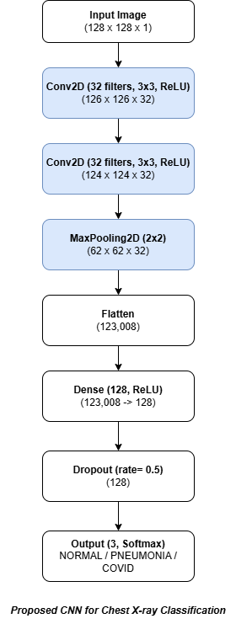

- Design your own complex CNN model using CNN blocks, convolutional, pooling, and fully connected layers to solve the given problem. Present and illustrate the architecture of your proposed CNN model. Example:

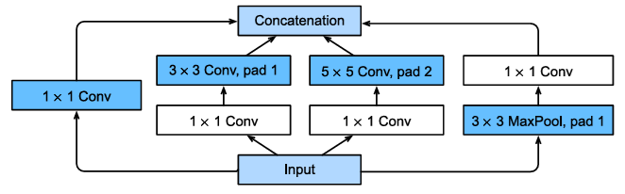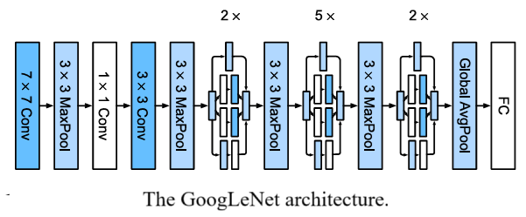

- Design a CNN model using Learning/Fine-Tuning to perform the given task. Present and illustrate the architecture of the proposed model. Example:

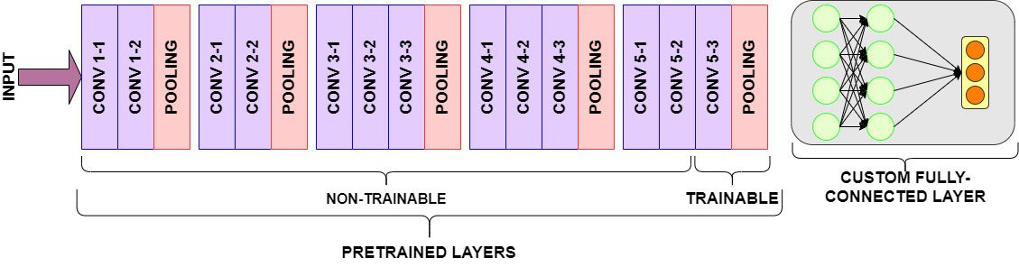

IV. Experimental Results
Evaluate the performance of the models on the test set. For example,
Model | Accuracy | Precision | Recall | F1-score
CNN | 0.96 | 0.96 | 0.96 | 0.96
CNN+Aug+Trans

V. Conclusion
Summarize the main results achieved by the team.
References
List all references used in the report.

